CENWP-OD-B 21 June 2023

MEMORANDUM FOR THE RECORD

SUBJECT: 23BON032 MFR AFF Valve 15 Pacific Lamprey Mortalities

On 20 June, Columbia River Inter-Tribal Fish Commission (CRITFC) Biologists notified Bonneville Project Biologists of three lamprey mortalities found on the valve 15 trash rack in the Adult Fish Facility (AFF). The fish were scanned for PIT tags, inspected, and returned to the river.

- Species – Pacific Lamprey (Entosphenus tridentatus)
- Origin – Unknown
- Length – In descending order: 71.1 cm, 71.8 cm, 69.9 cm
- Marks and tags – None
- Marks and Injuries found on carcass – Head contusion, bleeding from mouth, uppermost lamprey pictured (Figure 1.)
- Cause and Time of Death – Unknown
- Future and Preventative Measures – None
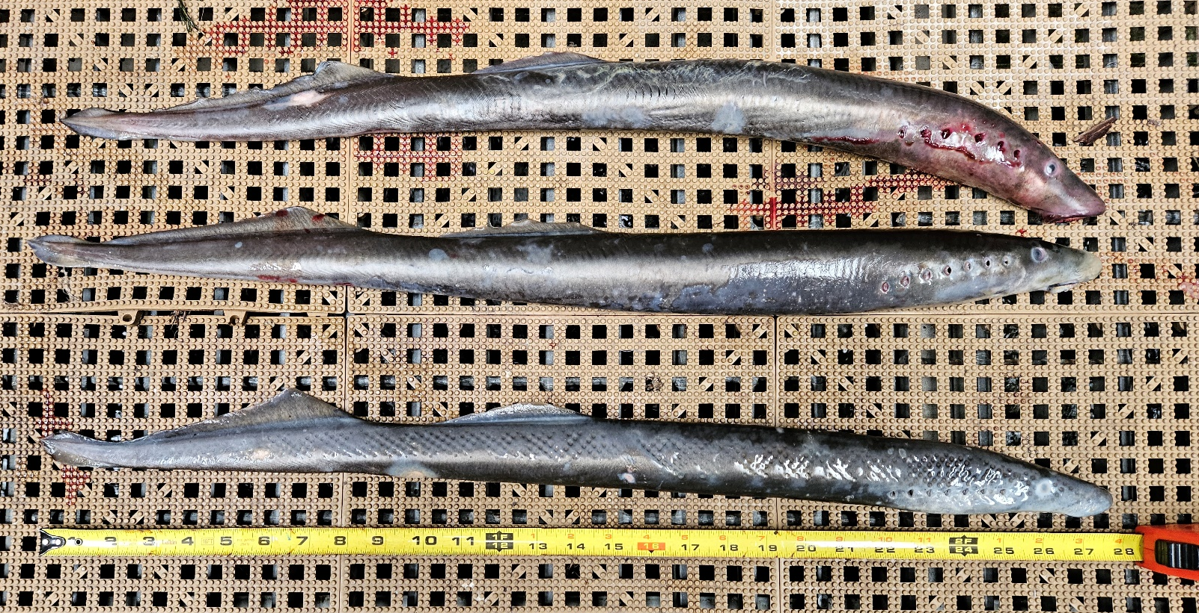
Figure 1.

Sincerely,
Bonneville Project Fisheries

